Tikka T3/T3X SwitchLug Installation Procedures

- Receiver preparation.
- Set up action in truing fixture, face off .100” from the action face to remove tapered surface. On CTR Rifles, the scope rail can be left fully installed. The front end of the rail can then be clearance cut as part of the facing op.
- If needed, re-cut the bolt lug abutments perpendicular to axial centerline and barrel tenon threads true to axial and rotational centerline at this time.
- Drill index pin holes in the action face, .300” deep at specified locations as shown in the picture below. Pin hole diameter to be .0938-.0945” max. We recommend spot drilling with a carbide center drill, then drilling to depth with an .0938” carbide straight flute drill and reaming as needed with an .0940 or .0945” for proper pin fit.
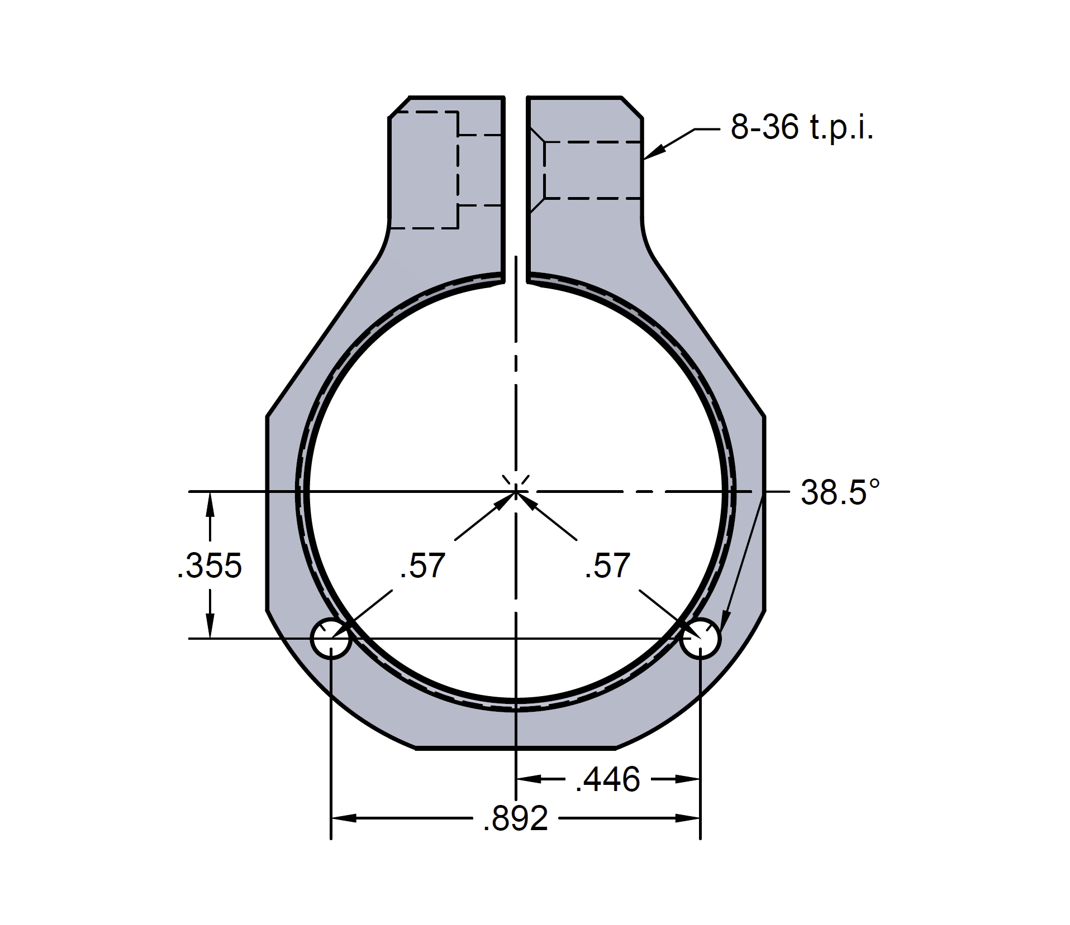
- Install index pins in receiver face, slip SwitchLug over index pins with the clamp screw facing to the RIGHT side of action, and check fit to trued action face

- Barrel thread tenon instructions.

- Turn threaded portion of barrel thread tenon to match your receiver’s thread specifications, ensuring the max OD of the thread tenon does not exceed 1.005”.
If you are using the factory tenon threads in the receiver without any additional recutting, the thread portion of the tenon should be .995” OD, 16TPI, with a thread pitch diameter of .960” maximum. The threaded portion of the tenon should be .900” in length, for a length including the lug interface of 1.250” total. Thread fit should have absolute minimum clearance for best repeatability, i.e. your action should screw onto thread tenon with no more than hand tightening force required, but have no discernable looseness.
- Turn SwitchLug mating surface. The mating surface should start at the end of the thread portion of the tenon, and extend .350” to the barrel torque shoulder. This is a tapered surface of 1 degree per side, with the taper opening toward the torque shoulder. Beginning OD of the mating surface must be 1.005” -.003”, tapering to a final OD of 1.015”-.003”. A relief cut at the torque shoulder/mating surface junction is not necessary as long as your turning tool has a nose radius of .016” or less.

- Coating

- When Cerakoting/painting a Switchlug enabled rifle, it is best practice to sandblast and coat the barrel separate from the receiver, if possible. This reduces the possibilities of blasting media from binding up between the switchlug and the surface on the barrels tenon. A commonly employed practice is to use an old take off barrel as a mandrel for the action and Switchlug. For the barrel, protect the barrel tenon either by masking off or use of a barrel tenon thread protector that can be tightened all the way to the torque shoulder. Detail clean all surfaces after blasting and before paint, to ensure no blasting media remains in any of the internal surfaces. Before assembly, clean the threaded area of the switchlug that houses the Lock Screw. Ensure the threads are completely clean to reduce galling on either thread, from blasting media being missed in this area.

- Operation.

To install a barrel:
- Apply a light amount of anti seize compound to the tenon threads and lug interface surface.
- Loosen the SwitchLug clamp screw until the screw can move freely.
- Screw in the rifle barrel and tighten hand tight against the front face of the SwitchLug.
- Once the barrel is hand tight, Torque the clamp screw to 30 in. lbs. The rifle can then be zeroed and used for normal operation.
- To remove a barrel, loosen the lug clamp screw until it can move freely, then unscrew the barrel by hand.

For any questions or technical assistance, please call (432)517-0592 or email us at texasordnance@hotmail.com.

